UniChat - Everything You Need

Phase 2 Report - First Prototype and Heuristic Evaluation



Group 06

Igor Diniz - UP 202000162

João Pinheiro - UP 202008133

Ricardo Cavalheiro - UP 202005103

# Project abridged description

The goal of our project is to create an application designed to make it easier for students to communicate among them giving them a better academic experience.

Users must first authenticate using their sigarra account information. The platform will have different rooms that students are divided into based on their subjects which allows students of the same class to get to know each other and to talk about specific subject information such as the division of students into group projects or to discuss topics learned in class.

Our goal is to create a better environment for every student.

# Prototype’s Wireflow

* [Send a message and start a video call](https://youtube.com/shorts/n57EBaLJbJo)

# 

* [Show interest in an event](https://youtube.com/shorts/IKIsl3wz0mc)

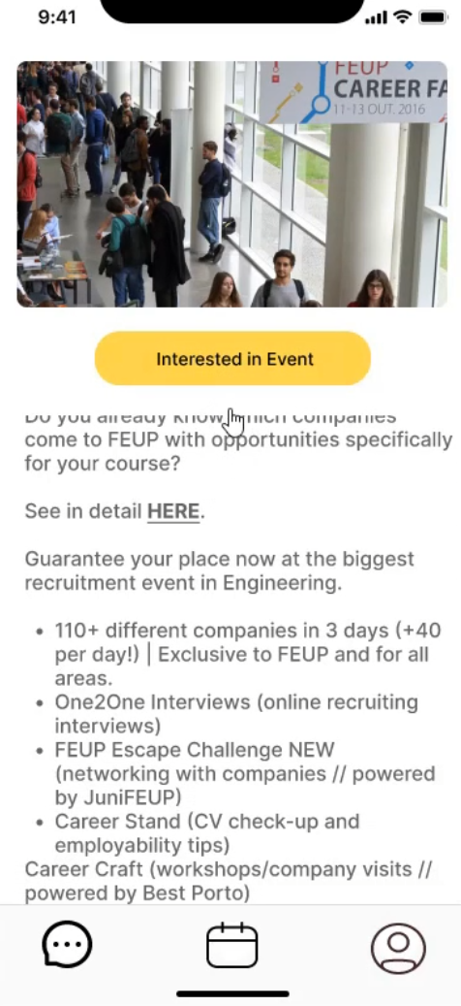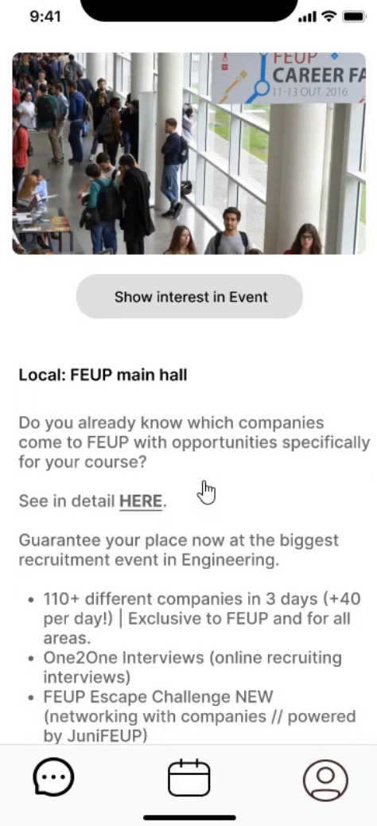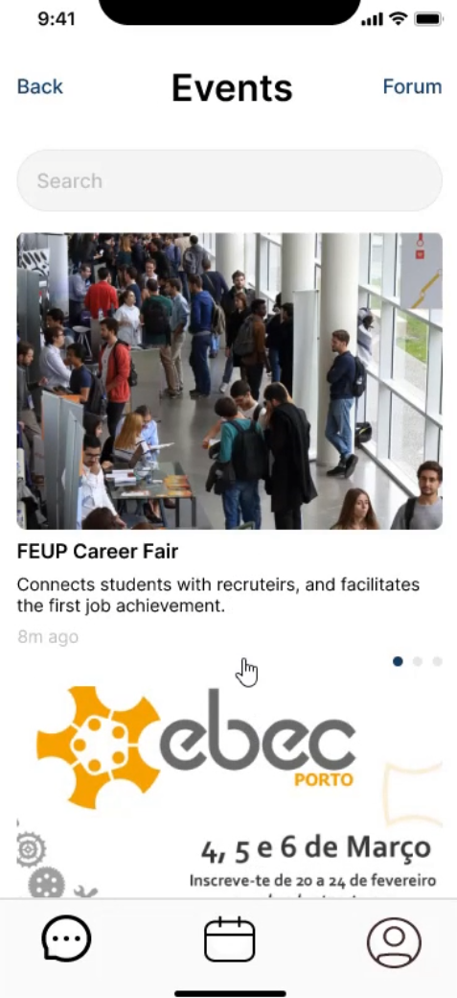



* [Access the forum](https://youtube.com/shorts/TFDf2OnzRII)

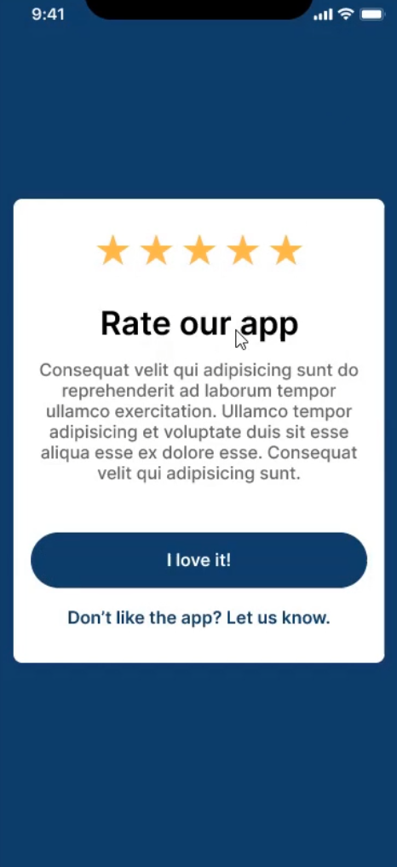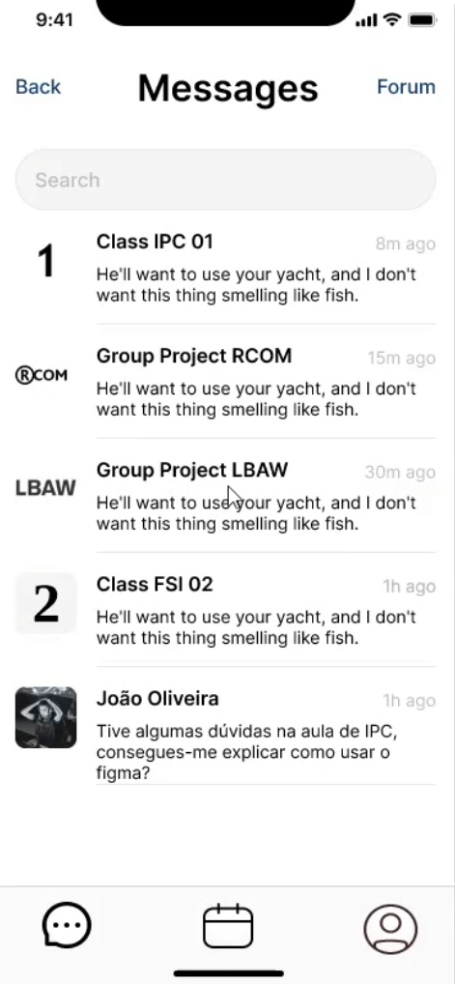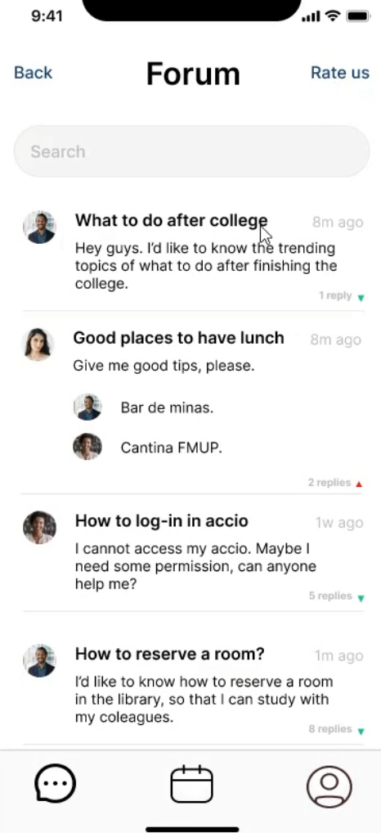





* [Search for messages and contacts](https://youtube.com/shorts/jvWXj3tS4dk)

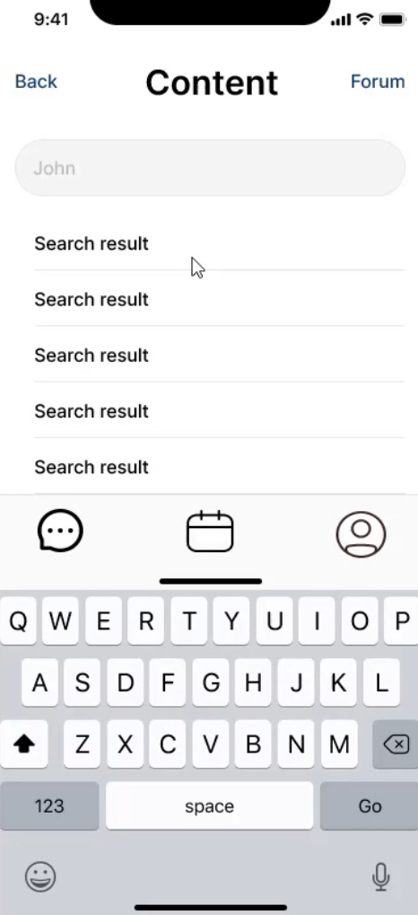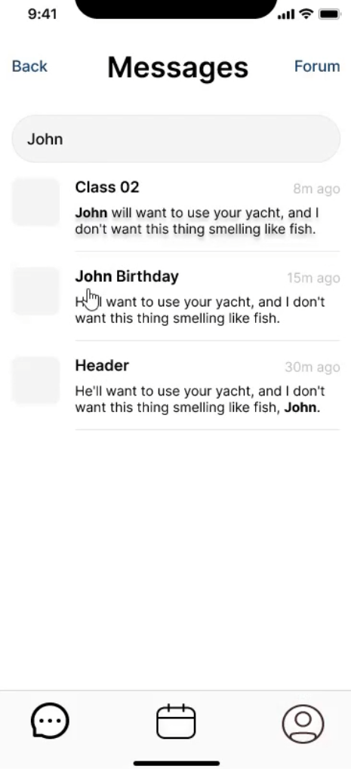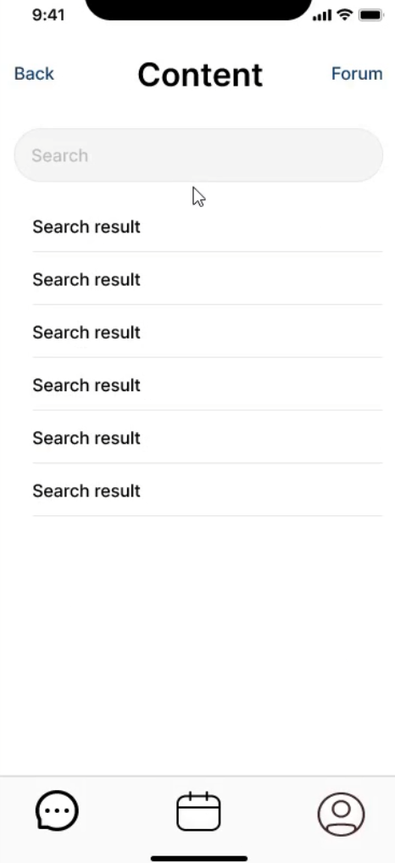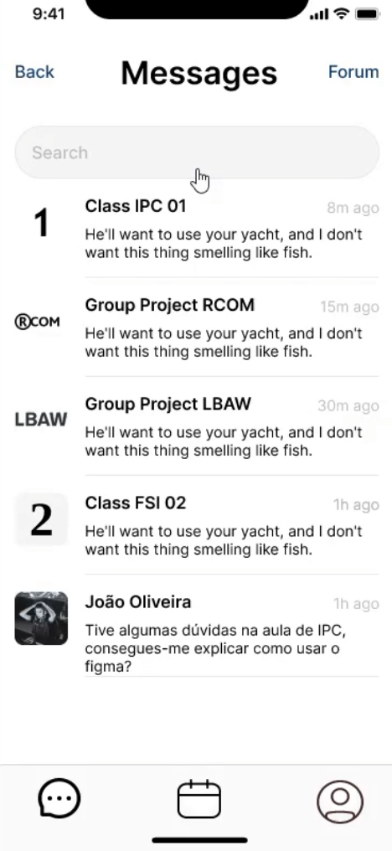



# Heuristic Evaluation Results

We were rated by groups 5 and 7 who gave us feedback on our app.

Group 5 identified that the bottom bar buttons did not show the correct page the user was on, which violates the visibility of system status heuristic. In addition, they recommended that we have a popup to confirm when the user wants to log out. Regarding this evaluation, we obtained a severity mean equal to 1.

On the other hand, we were also evaluated by group 7, which identified that the colors of the “Messages” menu are all dark and can quickly tire the user, which violates the aesthetic heuristic. Furthermore, they noted that the Forum button lacks the necessary evidence regarding its usefulness. This violates the efficiency of use heuristic. The group even went further and realized that there was no “Back” button on the “Events” page, as there was on other pages. This problem violates the user control and freedom heuristic. This same problem happened on the profile page, where we had a “Settings” button instead of a “Back” button which also violates the consistency and standards heuristic. After all this feedback, the severity mean we got from group 7 was 2.2.

# Corrections to perform in Phase 3

In order to improve our app, we should do the following improvements in the next phase:

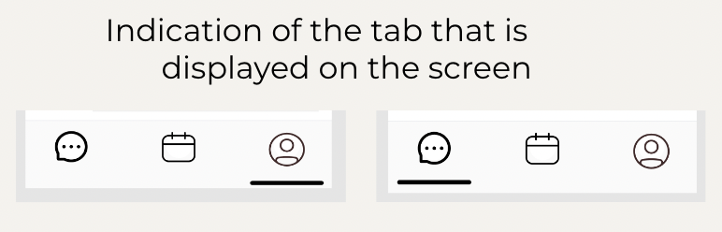

1. We should indicate the correct page where the user is in, doing it in the bottom bar buttons on our mobile app.

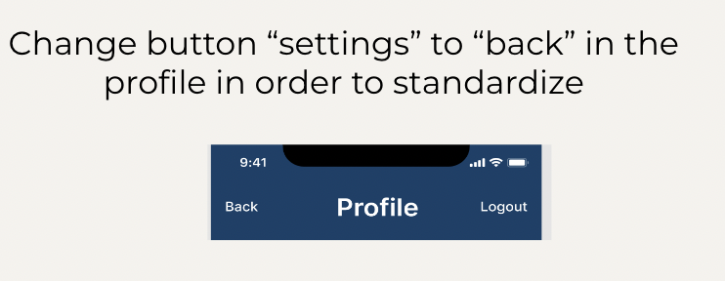

2. We should change the Settings button on the top left side of the page to the Back button so that we maintain the standard of use.

# 

# We need to add the top side buttons on the Event page in order to facilitate the navigation in our app.

# 

# 

# 4. We need to emphasize the forum button, since this is an important feature of our application.

# 

# 

# 5. We should include a pop up when the user is trying to logout of our application, in order to avoid errors and to maintain the user in our platform more time to help him.

# 

# 

# 6. We need to choose a more appealing color palette so we can transmit messages by them and so we avoid leaving the user in a boring state.

# 

# 

# 

# Conclusions

We realized through the evaluations on our application that we have some aspects to improve on color scheme, uniformizing the action buttons and displaying clear information about which screen the user is currently at for a better experience on the behalf of our users.

Nevertheless we concluded that our application was well achieved in terms of our objectives and its purpose. Finally with the corrections to be implemented in phase 3, UniChat would complete his intention on helping the academic community.

# Annexes

## Received Heuristic Evaluation Reports

### Group 5: [Heuristic Evaluation of Group 5](https://drive.google.com/file/d/1ksl8uVNAKG30P3xgsxPd9dY2vi-vYs4o/view?usp=sharing)

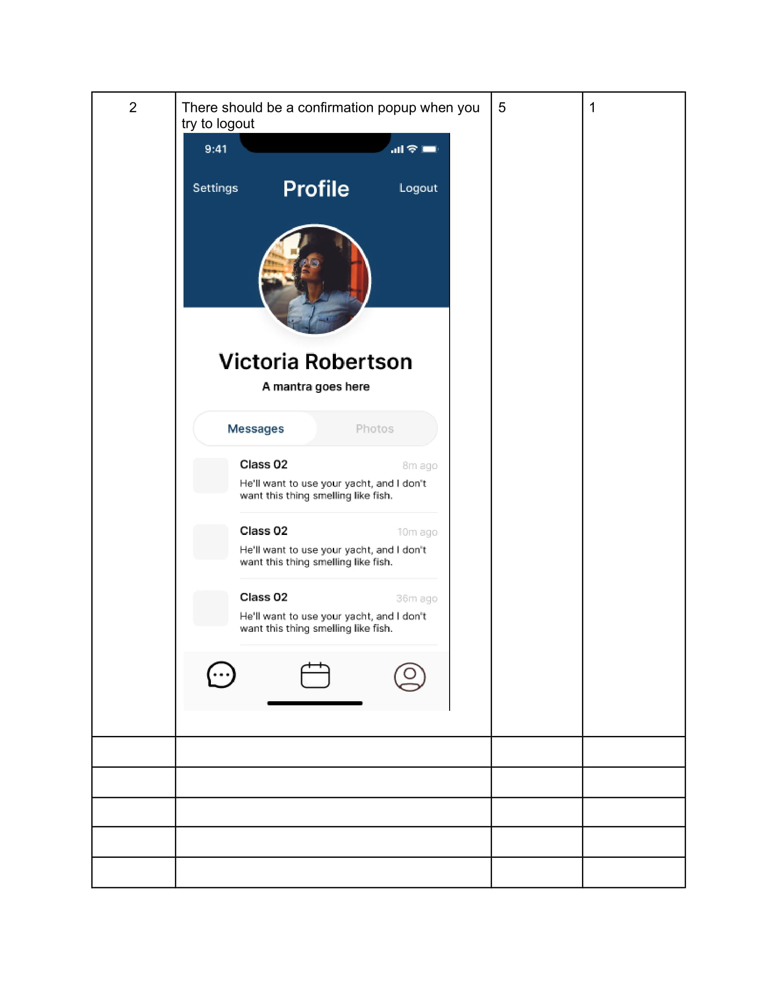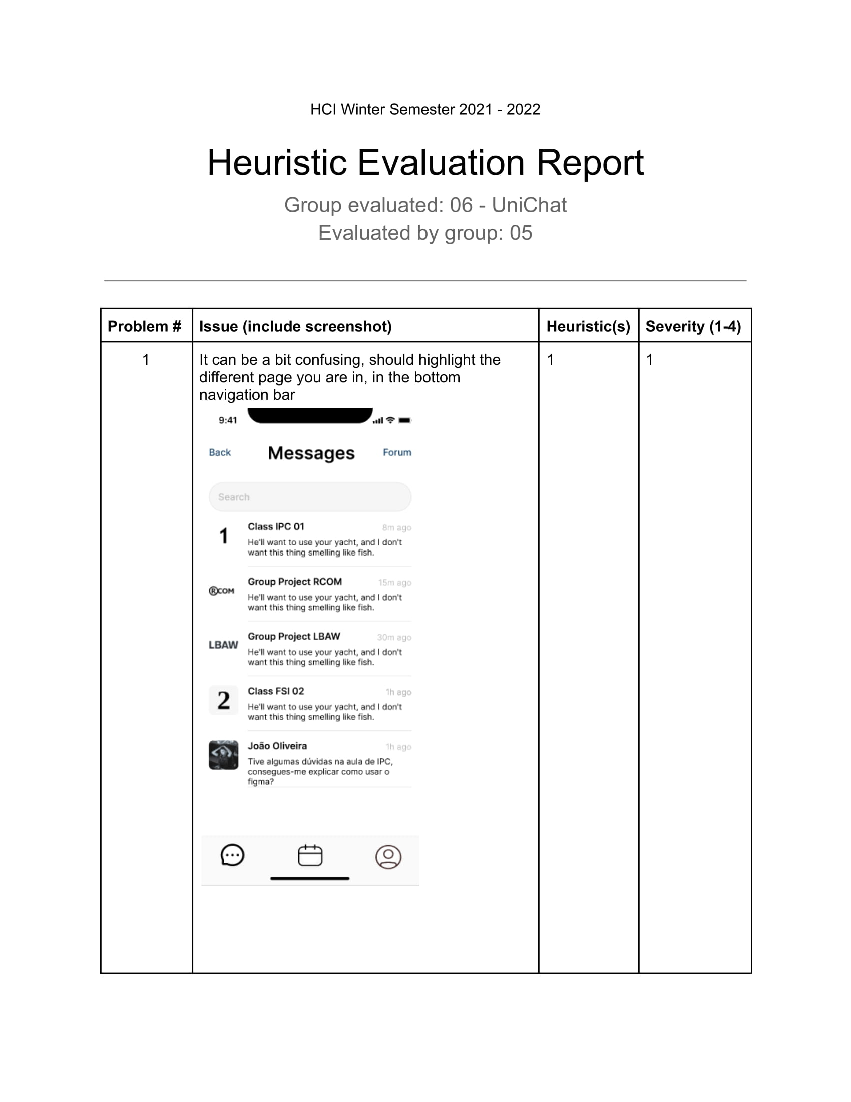



### Group 7: [Heuristic Evaluation of Group 7](https://drive.google.com/file/d/1e_IaqvL_1jbNoj744Oyuh-0LBgRb-q5a/view?usp=sharing)